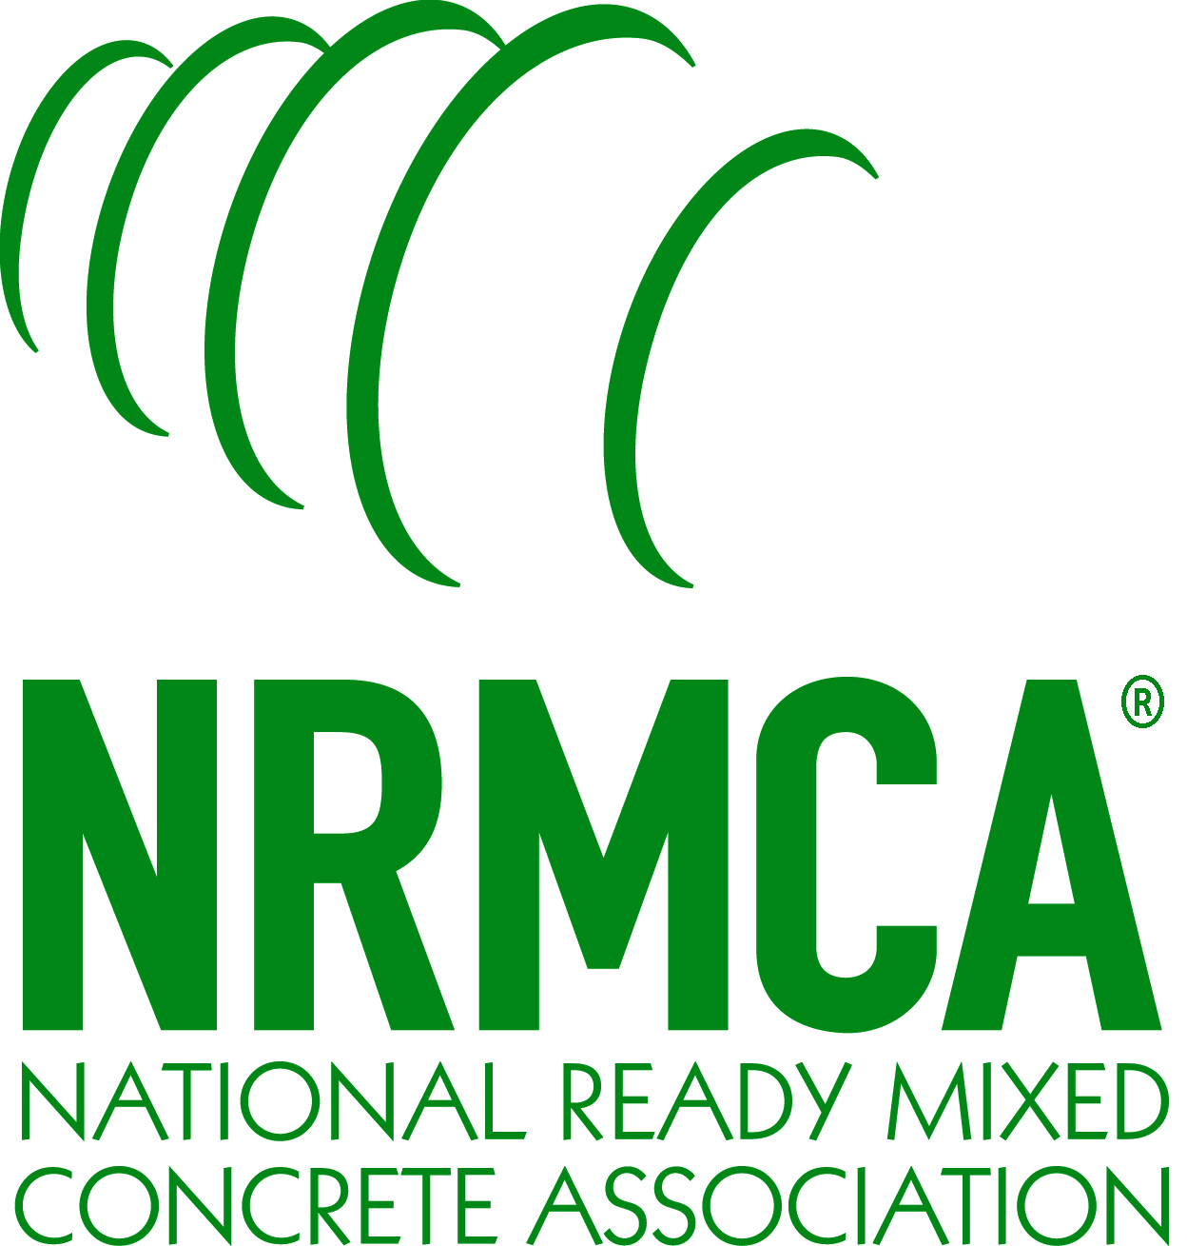**National Ready Mixed Concrete Association**

**Call For Nominations!**

**28th Annual Ready Mixed Concrete *Delivery Professional Driver of the Year***

**Program:**

The National Ready Mixed Concrete Association’s Ready Mixed Concrete Delivery Professional Driver of the Year Award acknowledges the significant contribution of ready mixed concrete truck drivers to the growth and success of individual companies and the ready mixed concrete industry. As a salute to these key members of the concrete production and delivery team, the award recognizes the driver’s career achievement, safety, professionalism, competence, and customer service skills in a manner that will enhance the industry and public image of the career Ready Mixed Concrete Delivery Professional. The award program is cosponsored by *Concrete Products* Magazine.

**Eligibility:**

The Driver of the Year competition is restricted to:

* Active employees of NRMCA member companies.
* Nominees must be full-time truck mixer drivers; Full-time drivers who fill in periodically as dispatchers, loader operators, etc., are eligible.
* One nominee per company per state. NRMCA encourages member companies to coordinate in-house competitions to select their nominee from each state in which they operate ready mixed concrete plants.
* Nominees must have at least five years of service to the ready mixed concrete industry.

**Award Categories:**

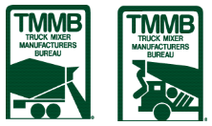Ready Mixed Concrete Delivery Professional Driver of the Year and Runners-Up shall be selected by the judges from the qualified nominees.

**Award Presentation:**

The 2024 Ready Mixed Concrete Truck Driver of the Year Award winner will be honored at an awards presentation ceremony at NRMCA’s Annual Convention in Tampa, FL in March 2024, and will be presented with a $5,000 check from the Truck Mixer Manufacturers Bureau (TMMB).

**Nominations & Deadline:**

Nominations can be made by completing the entry form on the back of this page and providing the required supporting testimonials from supervisor(s) and customers. Nominations must include two high-resolution electronic images of the driver-nominee: one dressed in his/her normal working attire with his/her truck, and another full-length photo of the driver in work clothes with the background of your choice. **Entries must be received via email by December 31, 2023.**

**JUDGING:**

A panel of judges assembled by NRMCA’s Operations, Environmental and Safety Committee will judge the competition. The panel of judges will be solely responsible for determining the award recipients and their decisions shall be final.

**More Information:**

Questions regarding this program should be directed to NRMCA’s Gary Mullings at (703) 706-4861 or via email at [gmullings@nrmca.org](mailto:gmullings@nrmca.org).

**2024 Driver of the Year**

28th Annual Ready Mixed Concrete Truck Driver of the Year

**Entry Form**

**Deadline: December 31, 2023**

1. Name of nominee _________________________________________________________

2. Employer company name ___________________________________________________

3. Company address _________________________________________________________

4. City ________________________________________ 5. State _______ 6. Zip_________

7. Nominee's home plant: City ____________________________________ State_________

8. Years of service to company (minimum 5)______________________________________

9. Total years driving a truck mixer ______________________________________________

10. Other types of equipment operated _____________________________________________

11. Years/months of driving service without a vehicle accident__________________________

12. Years/months of driving service without an on-the-job accident ______________________

13. Years/months of driving service without a rejected load ____________________________

14. Annual average yards of concrete hauled (last three years) __________________________

15. Licenses and/or certifications held (i.e., CDP, ACI Grade 1, NRMCA Level 2, etc.)

16. Special qualifications or other recognition (i.e., finalist in truck rodeo, employee of the year, community service recognition, etc.) ____________________________________________________________________________________________________________________________________________________________

17. Supervisor's comments (i.e., why this nominee should be selected as Ready Mixed Truck Driver of the Year. Comments should be typed, signed by the supervisor, and included with this form.)

18. Customer letters of compliment or testimonials. (Maximum of three, attached to this form)

19. Two (2) high-definition electronic photographs of the nominee:

a. Full-length photo of the nominee in work attire with the background of your choice

b. Photo of the nominee with his/her truck

Nomination submitted by: Name _________________________ Title_____________________

Address ______________________________ City ________________ State______ Zip______

Phone (______)___________________ Email: _______________________________________

**To submit a nominee, please email this form with any required attachments to NRMCA at** [**DOY@nrmca.org**](mailto:DOY@nrmca.org)**.**